Lab 9
Assume the following Ring topology. Make use of Dynamic Routing to make networks 10.0.0.0/24, 10.1.1.0/24 and 10.2.2.0/24 reachable to each other. The Network addresses seen in the box corresponds to the point-to-point network between devices. Use the following protocols:
1. Router Information Protocol
2. Open Shortest Path First
Apparatus Required
- Cisco Packet Tracer software (for simulation).
- Routers: 3 × Cisco 1941 routers.
- Switches: 3 × generic switches (optional, if PCs are directly connected, not mandatory).
- End Devices: 3 × PCs.
- Connecting Cables:
  - Copper Straight-through (PC ↔ Switch/Router Ethernet)
  - Serial DCE/DTE cables (Router ↔ Router point-to-point links)
Tools Used
- Cisco Packet Tracer Software
- CLI (Command Line Interface) of each Router for configuration
- Ping Command for connectivity testing
Theory
Routing Information Protocol (RIP):
Routing Information Protocol (RIP) is a dynamic routing protocol based on the distance-vector algorithm. It uses hop count as its metric, with a maximum of 15 hops, making it suitable only for small networks. RIP routers exchange their routing tables every 30 seconds to keep routes updated. There are two versions: RIPv1, which is classful and does not support subnet masks, and RIPv2, which is classless, supports VLSM/CIDR, and uses multicast (224.0.0.9) for updates. RIP is simple to configure and is commonly used in teaching and small networks despite being replaced in larger networks by more advanced protocols.
Open Shortest Path First (OSPF):
Open Shortest Path First (OSPF) is a link-state dynamic routing protocol that uses the Dijkstra shortest path algorithm to calculate the best route. Unlike RIP, which uses hop count, OSPF uses cost (based on bandwidth) as its metric, making it more efficient and scalable. OSPF has no hop limit and is suitable for medium to large networks.
Routers running OSPF exchange link-state advertisements (LSAs) to build a complete map of the network, known as the link-state database (LSDB). This allows OSPF to converge quickly when network changes occur. OSPF is a classless protocol, supporting VLSM and CIDR, and it sends updates only when changes happen, not periodically like RIP. It also supports dividing a network into areas, with Area 0 as the backbone, which improves performance and reduces overhead.

Lab Diagram:
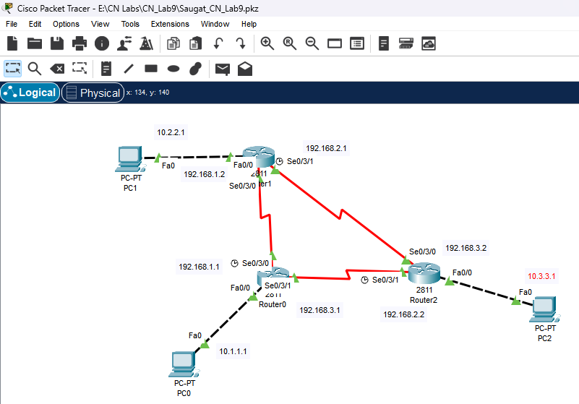

Procedure:
1. Create the Topology
- Open Cisco Packet Tracer.
- Place three routers (R1, R2, R3).
- Connect the routers in a ring using Serial DCE/DTE cables (red cable).
- Attach one PC to each router using a Copper Straight-Through cable on the FastEthernet interface.
2. Configure Router Interfaces
In router1(Saugat-rw1):
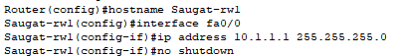
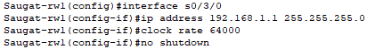
In router2(Saugat-rw2):
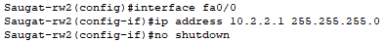
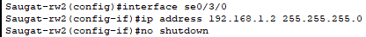
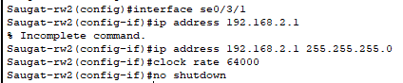

In router3(Saugat-rw3)
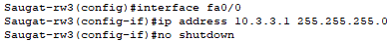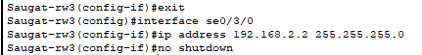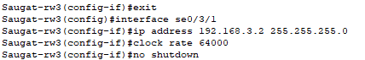
3.Configuring DHCP :
In router1(Saugat-rw1):
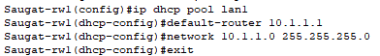
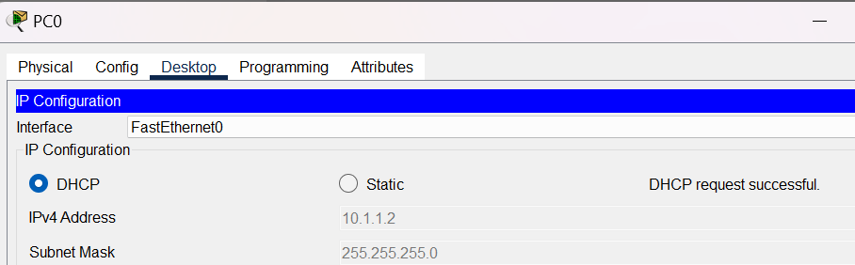
In router2(Saugat-rw2):
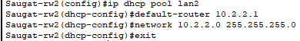
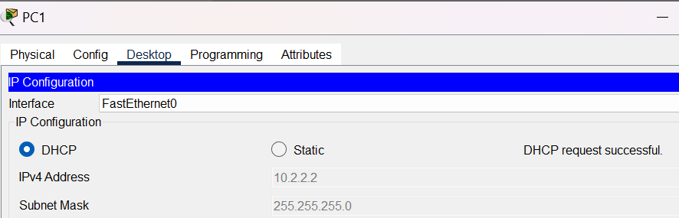
In router 3(Saugat-rw3):
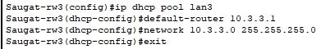
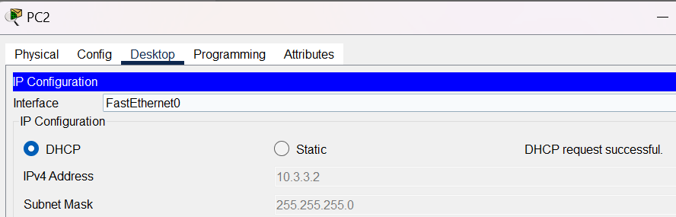
4. RIP v2 Config
In router 1:
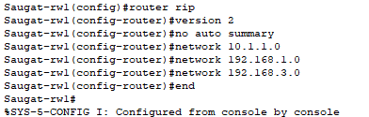
In router 2:
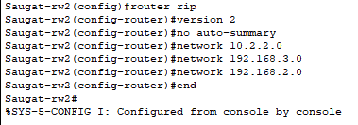

In router 3:
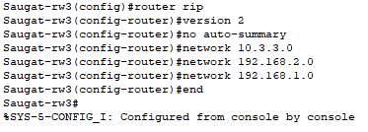
4.OSPF Config:
In router1(Saugat-rw1): 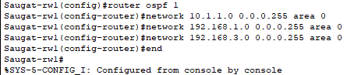
In router2(Saugat-rw2): 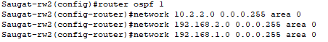
In router3(Saugat-rw3):
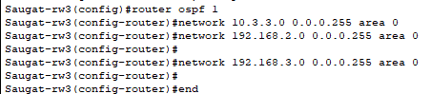
Testing for RIP :
1.ip route
In router1(Saugat-rw1):
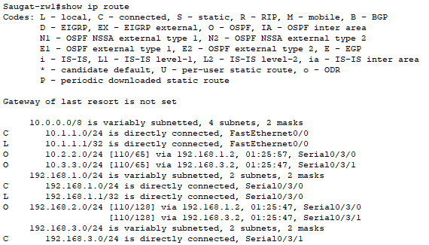
In router2(Saugat-rw2):
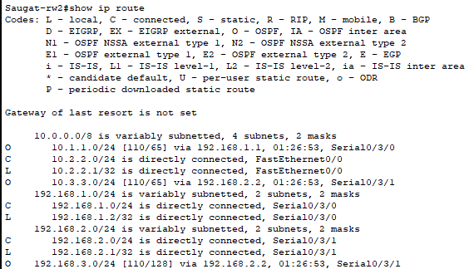
In router3(Saugat-rw3):
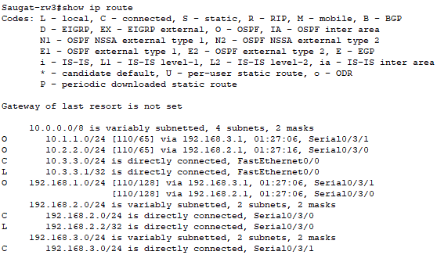

2.ping test:
From pc0 in router1(10.1.1.2):
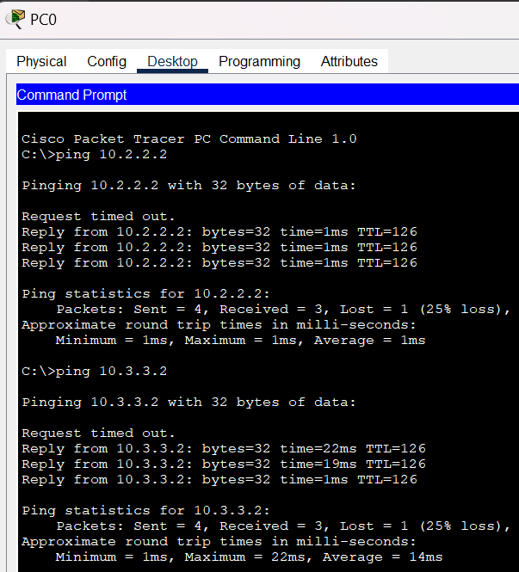
From pc1 in router2(10.2.2.2):
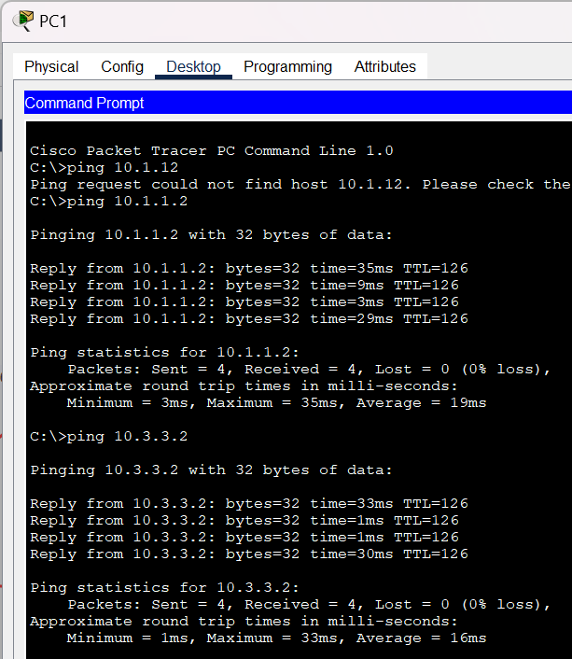
Ping from pc2 in router3(10.3.3.2):
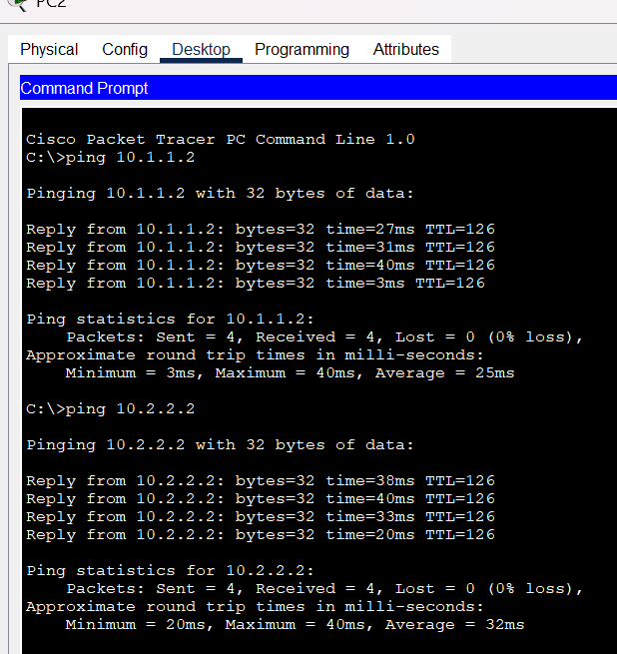
Testing for OSPF:
1.ip route
In router1(Saugat-rw1):
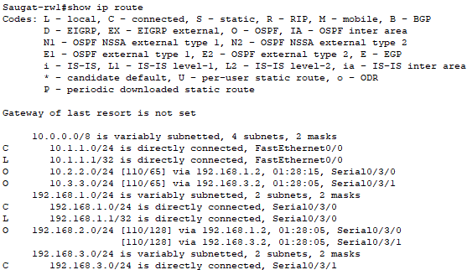
In router2(Saugat-rw2):
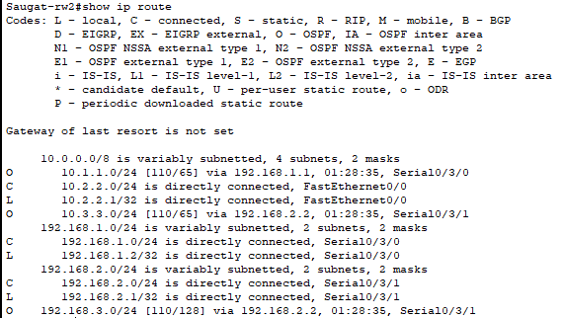
In router3(Saugat-rw3):
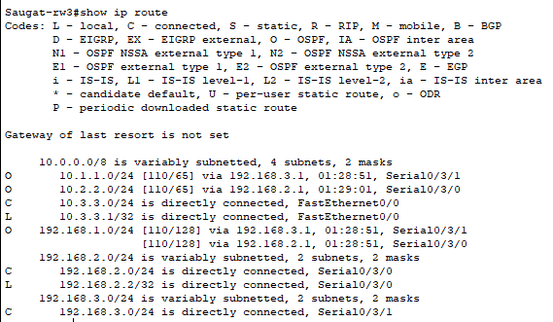

3.ping test:
From pc0 in router1(10.1.1.2):
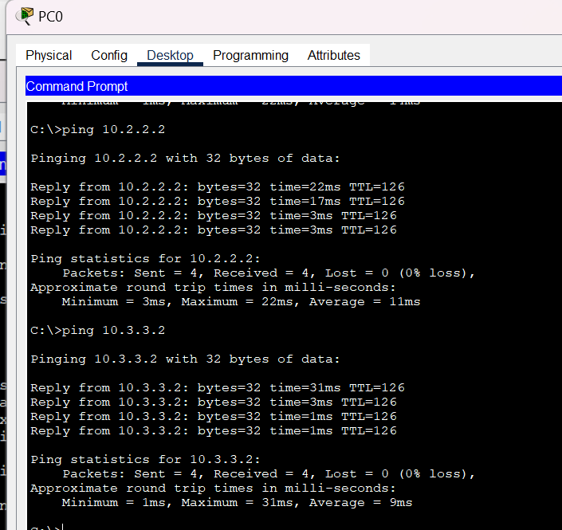
From pc1 in router2(10.2.2.2):
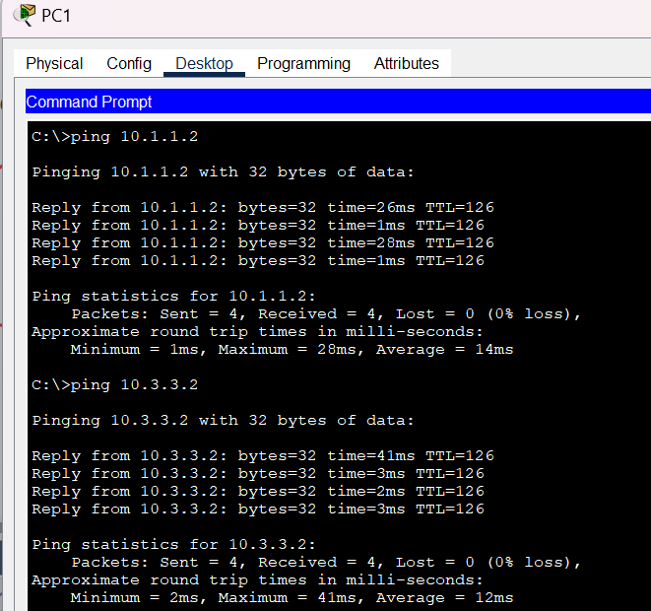
Ping from pc2 in router3(10.3.3.2):
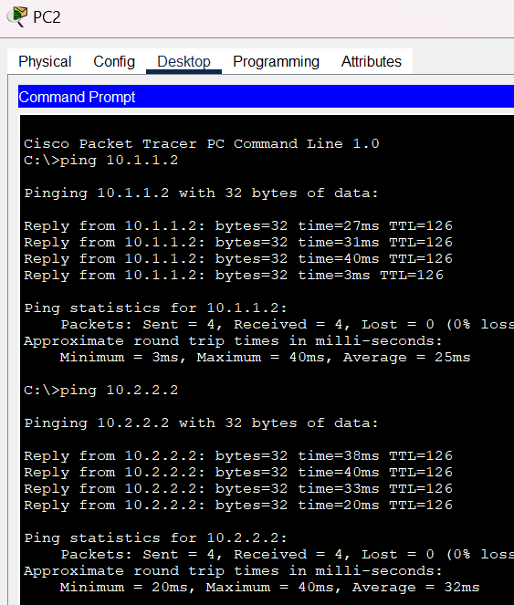
Conclusion:
In this lab, both RIP and OSPF were successfully configured to enable dynamic routing between all three routers. For RIP, after correcting the network statements to include each router’s LAN and serial interfaces, all networks (10.1.1.0/24, 10.2.2.0/24, 10.3.3.0/24) became reachable, demonstrating its simplicity for small networks despite using hop count as the only metric.
OSPF was then implemented as a link-state protocol, providing faster convergence and more efficient routing. By configuring all interfaces in a single area with correct wildcard masks, routers exchanged LSAs and built complete routing tables, ensuring all LANs were reachable and highlighting OSPF’s scalability and suitability for larger, more complex networks.

